Figure S3 Gene annotation analysis in PW5/Model (A) and WN5/Model (B) groups
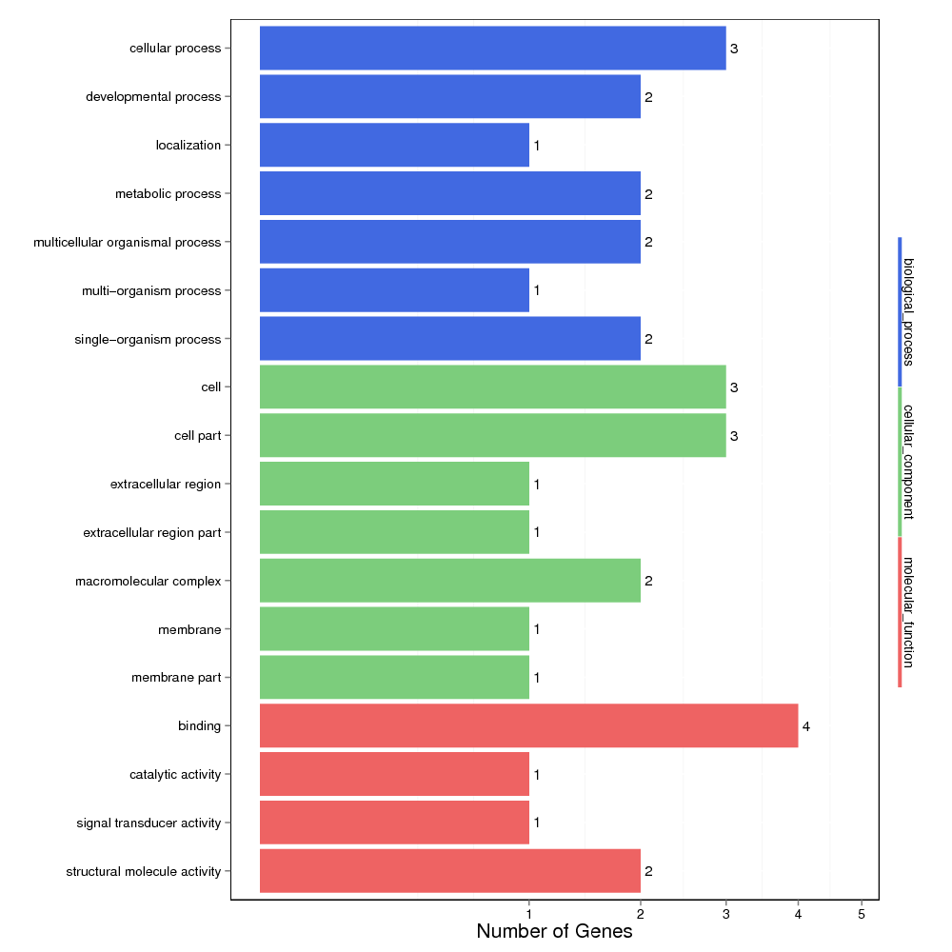
- Gene annotation analysis in PW5/Model group
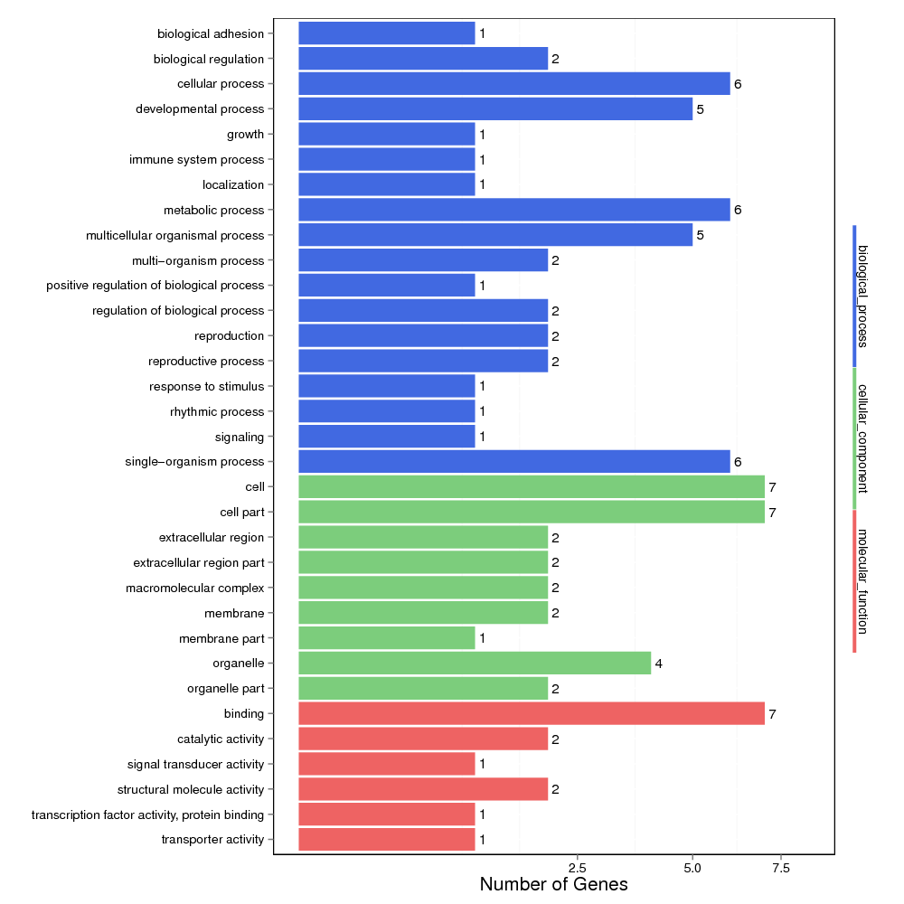
- Gene annotation analysis in WN5/Model group

