Figure S1 Correlation coefficient value distribution in heatmap of Model, PW5 and WN5 groups
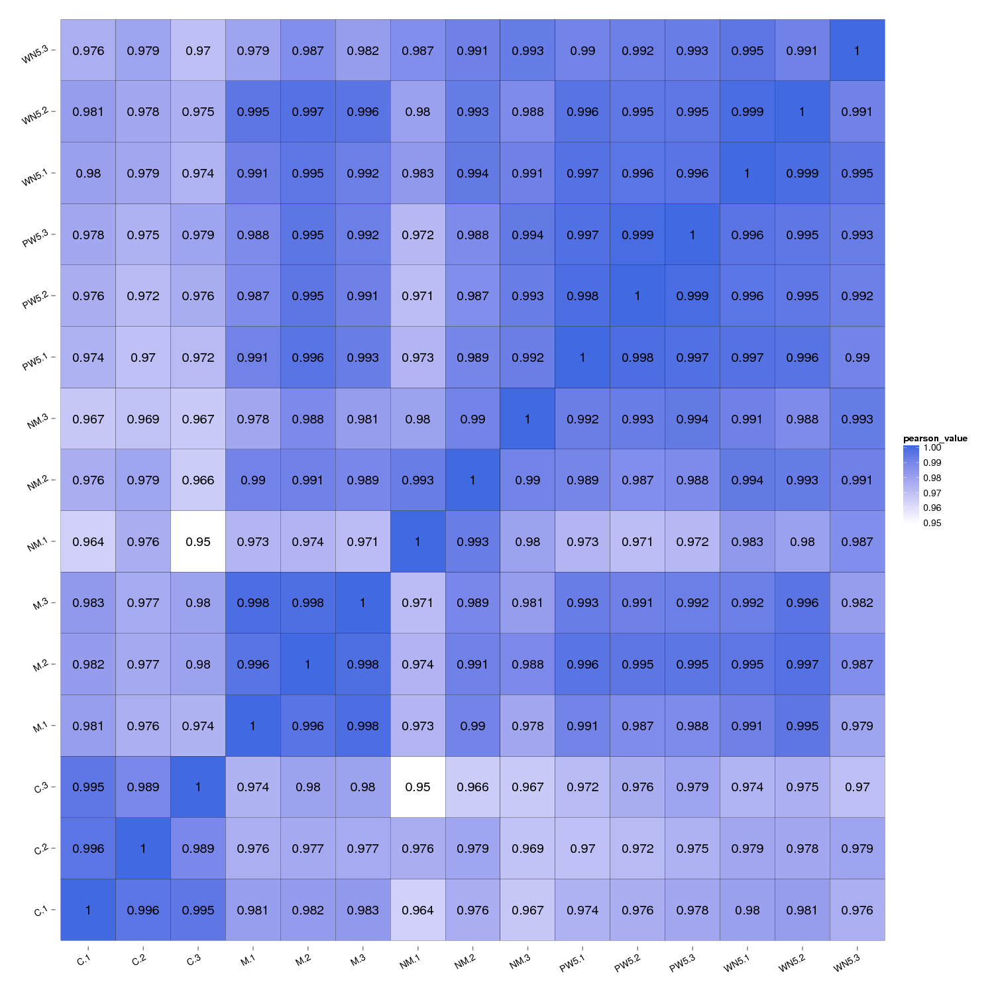
Note: C represented as Control group (Aβ42-WT, no abnormal protein aggregates in cells); M represented as Model group (Aβ42-E22G mutant, abnormal red protein aggregates in cells); NM represented as non-induced Model group (without tetracycline induced leading to no red proteins aggregates in cells).

